Ministry of Higher Education, Science, and Technology
Strengthen University Teaching Hospitals in the Fight against COVID-19 and Pandemic Preparedness
Procurement of Medical Equipment for ICU for severe COVID-19 Cases/Infectious Disease and BSL3 Laboratory for Virology Diagnostics (UNHAS), Makassar, South Sulawesi, Republic of Indonesia
ICB No. EU-UNHAS-48511-GOODS1 / KfW Tender ID: 511657
Circular 4
N° | Question | Answer
11 | On Form ELI - 1.2: JV Bidder Information Form, is the signature of only the Bidder, or only the JV Member, or is the signature of both the Bidder and the JV Member? | Please refer to the Bidding Document, Section I [Instructions to Bidders], 20 [Format and Signing of Bid], 20.3 “In case the Bidder is a JV, the Bid shall be signed by an authorized representative of the JV on behalf of the JV, and so as to be legally binding on all the members as evidenced by a power of attorney signed by their legally authorized representatives. If the JV has not been legally constituted into a legally enforceable JV at the time of bidding, then the Bid shall be signed by every member of the proposed JV”,  Form ELI – 1.2, Section IV [Bidding Forms], Form ELI - 1.2: Bidder's JV Information Form, refers to “the person signing the Bid” as follows.  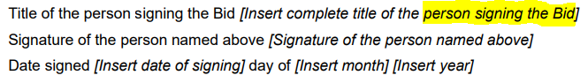  With the intention to give an exact answer to the specific question, if the Bidder is a Joint Venture, the Bid (as well as all documents forming the Bid, including but not limited to ELI – 1.2) shall be signed by “an authorized representative of the JV on behalf of the JV, (…) as evidenced by a power of attorney signed by their legally authorized representatives” (this power of attorney shall be part of the Bid, clearly confirming the authorization to sign on behalf of the JV as the Bidder, to be established in the name of the signatory of the Bid).

