Ministry of Higher Education, Science, and Technology
Strengthen University Teaching Hospitals in the Fight against COVID-19 and Pandemic Preparedness
Procurement of Medical Equipment for ICU for severe COVID-19 Cases/Infectious Disease and BSL3 Laboratory for Virology Diagnostics (UNHAS), Makassar, South Sulawesi, Republic of Indonesia
ICB No. EU-UNHAS-48511-GOODS1 / KfW Tender ID: 511657
Circular 2
N° | Question | Answer
6 | Regarding the letter of support that will be provided by the manufacturer, principal, or distributor, if the bidder is in a JV, is the support only for the bidder, or must it be for both the bidder and the JV? | We understand you refer to the Bidding Document, Section I [Instructions to Bidders], 17 [Documents Establishing the Eligibility and Qualifications of the Bidder], 17.2, Section IV [Bidding Forms], Manufacturer’s Authorization and circular 1, Answer to Question N° 3.  Please refer to the Bidding Document, Section I [Instructions to Bidders], 4. [Eligible Bidders], 4.1 “A Bidder may be a firm that is a private entity, a state-owned entity- subject to ITB 4.3 - or any combination of such entities in the form of a joint venture (“JV”) under an existing JV Agreement or with the intent to enter into such an agreement supported by a letter of intent to execute a JV Agreement, in accordance with ITB 11.2. In the case of a JV, all members shall be jointly and severally liable for the execution of the Contract in accordance with the Contract terms. The Bidder shall nominate an authorised representative who shall have the authority to conduct all business for and on behalf of Bidder and any and all its members, if the Bidder is a JV, during bidding and contract execution (in the event the Bidder is awarded the Contract). Unless specified in the BDS, there is no limit on the number of members in a JV.”  With the intention to give an exact answer to the specific question, if the Bidder is a Joint Venture, the required Manufacturer’s Authorizations or any relevant “letter of support” shall authorize to the Joint Venture and clearly state the name of the Joint Venture, which is severally liable for the execution of the Contract.
7 | Regarding the Financial Report, is it the same? The report provided only covers the bidder's cash flow, or must it include the JV company's financial report if they are collaborating? | We understand you refer to the Bidding Document, Section III [Qualification and Evaluation Criteria], 1.2. Requirements and Criteria, Table 3 [Financial Situation and Performance], 3.1. Financial Capabilities “Submission of audited balance sheets or if not required by the law of the Bidder’s country, other financial statements acceptable to the Purchaser, for the last 3 years to demonstrate the current soundness of the Bidder’s financial position (…)” the criteria 3.1 applies to all members of a Joint Venture as a must meet requirement.  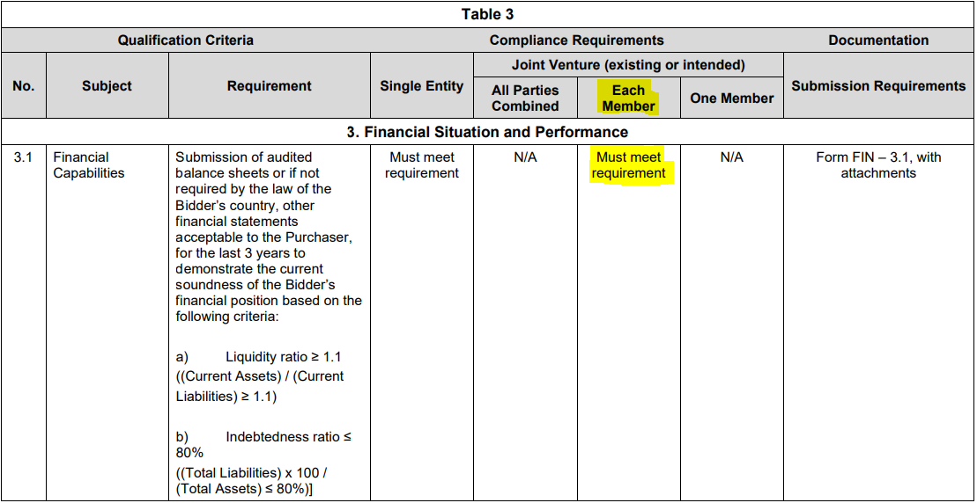
8 | Regarding the Document Number, should we use  - ICB Number: EU-UNHAS-48511-GOODS1 / KfW Tender ID: 511657  or this one?  - The number of the Invitation for Bids is: EU-UNHAS-48511-GOODS1 | Please use:  EU-UNHAS-48511-GOODS1 as per the Bidding Document, Sections II [Bid Data Sheet] and IV [Bidding Form].
9 | The item code BOTM041, No. 10 The Name is Endoscopic Column with Bronchoscope, differs from the specifications listed in the TECHNICAL SPECIFICATION FORM (TSF) in a Document. Even though the item is categorized major, Which should we follow in this regard? The product Description (Endoscopic Column with Bronchoscope) or The specifications listed in the TSF? | Concerning the item code BOTM041, the Name “Endoscopic Column with Bronchoscope” is correct.  Please refer to the corrected technical specification in form of the revised TSF (for Endoscopic Column with Bronchoscope) attached.

